Intro to AI LLM Systems with Ollama and Python
Last Edited: Tuesday, October 7, 2025
Table of Contents
Introduction 2
Why “AI” 2
Building an AI System 3
LLM’s 3
WARNING 4
Ollama 5
Ollama and Python 7
LLM Injection 8
Injecting Rules 9
Dynamic Injection with REST API 11
LLM Memory 13
Cleaning Up Input Data - BeautifulSoup 15
LLM Web App with Bottle Framework 17

Setup

For this class you will need a Windows/Mac/Linux computer with over 8GB of RAM. The better the computer you have the better performance you will get, but these projects should run on almost any system.

You do not need an NVIDIA GPU or high end GPU.

You will need to install the Ollama Framework from ollama.org

You will need to install/pull the phi3 model, and the gpt-oss model.

You will need VSCode installed on your system with the Python Extension added.

For Python the Modules you will need are:
- ollama
- requests
- beautifulsoup4
- bottle

Introduction
LLM’s are a single component of an “AI” system. Much like the database is one component of a CRM solution.
The solutions such as ChatGPT are built with numerous different technologies beyond the LLM.
This class will demonstrate building components for an “AI” system.

Why “AI”
LLM’s turn words, parts of words and symbols into tokens. It then determines the statistical relationship between those tokens. The response you receive is the LLM collecting and ordering tokens and then correlating those tokens to words.
LLM’s are not racist, sexist, good or evil. They are basically really complicated calculators. You don’t blame a calculator for a 13 year old boy typing in 8008.
The results that the LLM provide will be skewed by the data it was trained on. Some LLM’s are trained on the contents of the “web” and may provide responses closer to a Reddit thread than you prefer. Models such as IBM’s Granite are trained only on business communications and therefore will output responses that appear more forma and corporate.
Outputs are biased by training data in ways that may be unexpected. (STORY TIME – Stories based on race)
You need to test your AI products on a diverse user group that closely emulates your user base, and skews to poor reception from users to find any “gotchas”. They keep geeks separated from the normies for a reason! (STORY TIME – Monkeys don’t exist)
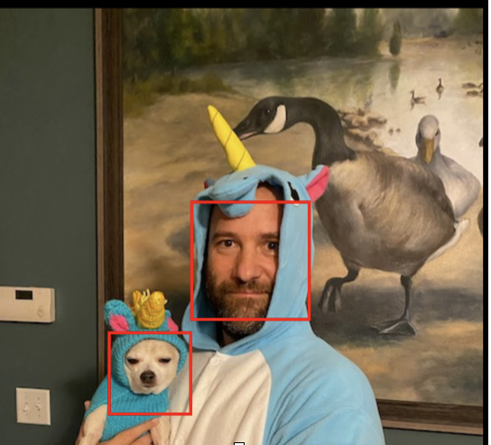Figure 1: OpenCV Human Face Recognition: Cute or Vile

Building an AI System
When you build an “AI” system you will combine numerous technologies to create your solution.
- The LLM will be used for the language processing for input and output
- Python or other language will be used to interact with the LLM
- Bottle or other Framework will turn the Python code into a Web Application.
- REST or other API’s can be used to dynamically pull in information about the user to add to the prompt.
- Filters will be used to block inappropriate requests. These can be from simple filter lists, or by even using an LLM to determine if the query falls within a set of rules.
- Databases or record stores can be used to create a “memory” of the conversation
- RAG or other methods can be used to provide specific data to the LLM for answering questions.
- Output Datastores or Databases

LLM’s – Large Language Models
Size
When discussing LLM’s you will here about how many billion parameters the model was trained on. 2b, 7b, 480b. The larger the model the more GPU resources will be required to complete prompts. We will use Microsoft’s Phi3 model which is 3.8b and will run on a Raspberry Pi or a 2012 MacBook Pro.
It has been considered that larger models are “better”. With new training techniques smaller models are now performing better than some larger models. Also as a tech professional the goal is to use the fewest resources to provide a required outcome. If a 2b model provides accurate and reliable output then there is no reason to run a larger model.
All models “behave” differently. When writing code that parses or tests against returns you may find switching to a different model creates issues and can be difficult to test and verify.
Quantization
Quantization is a process for compressing models. Generally it is considered that a GPU should have the VRAM of the same size as the billions of parameters for a model. So a 14b model would need 14GB of VRAM. Quantizing allows the model to be run on less VRAM. Results are considered to be of lesser quality, but that may not be relevant for your project.
Context Window Size
Context Size is the total number of tokens that can be sent to the LLM at one time. 1000 tokens equals approximately 750 words. Larger Context Windows allows for more complex queries, but require more resources. This is why we use tools to only provide the information that’s needed.
If you ask a question about a web page and send the entire web page in the context window it will be over 20,000 tokens for even a simple page. The full page contains not just the viewable web page content, but also the CSS, JavaScript and other text for formatting and such. By using a Python Module like Beautiful Soup you can pull just the viewable text, and send only that to the LLM.
Prompt Engineering vs Context Engineering
Prompt Engineering refers to formatting the prompt that is sent to the LLM in such a way as to provide rules for how the results should be returned. This is generally used to keep a return from being too long. You can do a Prompt Injection that adds additional commands automatically to a users prompt.
Context Engineering refers to modifying all of the data that is being sent to the LLM. This can mean adding a “memory” of the conversation up until this point, adding dynamic data from an API or data store, or adding information for the LLM to answer the question from such as with RAG.

WARNING
Things change nearly daily in the “AI” world. This is not a figure of speech!
The function calls for connecting to LLM’s and API’s change regularly and also the response formats. When I create classes for Python or SQL I don’t have to change much over years. With “AI” many times code that worked a few months ago will no longer function.
Testing and version controls are vital for putting systems into production even at small scale.

Ollama
Ollama is a framework that allows you to run LLM’s and other AI models locally. It can be run on Windows, Mac and Linux. It will run LLM’s using CPU only if it can’t find a compatible GPU.
Install
Once installed you will interact with Ollama on the CLI
https://ollama.com/

Pull/ Install Model
ollama pull MODEL

eli@osx ~ % ollama pull phi3
pulling manifest
pulling 633fc5be925f: 100% ▕████████████████▏ 2.2 GB
pulling fa8235e5b48f: 100% ▕████████████████▏ 1.1 KB
pulling 542b217f179c: 100% ▕████████████████▏ 148 B
pulling 8dde1baf1db0: 100% ▕████████████████▏ 78 B
pulling 23291dc44752: 100% ▕████████████████▏ 483 B
verifying sha256 digest
writing manifest
success

Run Model (If model is not installed it will be downloaded)
ollama run MODEL

eli@osx ~ % ollama run phi3
>>> Send a message (/? for help)

Exit
/bye

List Installed Models
ollama list

eli@osx ~ % ollama list
NAME ID SIZE MODIFIED
gpt-oss:latest aa4295ac10c3 13 GB 21 hours ago
gpt-oss:20b f2b8351c629c 13 GB 8 weeks ago
phi3:latest 4f2222927938 2.2 GB 3 months ago
phi:latest e2fd6321a5fe 1.6 GB 6 months ago
llama3.1:latest 42182419e950 4.7 GB 12 months ago

Ollama and Python
You can interact with Ollama from Python scripts. You will need to install the Ollama Module into your Python enviornment.
Ollama needs to be running for Python to interact with it. Start Ollama with the LLM you will be using in the script.
Install Ollama Module
python3 – m pip install ollama

Python Code
This code imports the chat and ChatResponse modules. The chat module interacts with Ollama and the ChatResponse module formats the return as a class.
response: assigns the value of the Ollama return as a type of Class to the variable response.
model= is where you state what LLM model to use.
role: leave as ‘user’
content: is the query itself that is sent to the LLM
The response value that is returned is a full Class. To access the “content” portion which is only the answer you use response.message.content
Previously you used response['message']['content'], and it still does work. This seems to have gone out of fashion with the different LLM providers such as the OpenAI API.

from ollama import chat
from ollama import ChatResponse

response: ChatResponse = chat(model='phi3', messages=[
{
'role': 'user',
'content': 'Why is the sky blue?',
},
])

print(response['message']['content'])
# or access fields directly from the response object
print(response.message.content)

print(response)

LLM Injection
This example adds an injection to the prompt. We are going to ask for the response to be 20 words or less.
We will also add a while True loop to this example so that you can ask queries one after the other to see how the LLM responds.
To insert the Injection we will set the value of the query sent to be the injection with the query appended to it. For this we will use an f string to concatenate the text.
The query with the injection will then be sent to a custom function which will send the query to Ollama and provide the response.
ollama-injection.py
from ollama import chat
from ollama import ChatResponse

injection = 'Answer in Fewer Than 20 Words'

def ai(query):
response: ChatResponse = chat(model='phi3', messages=[
{
'role': 'user',
'content': query,
},
])

return response.message.content

while True:
query = input('How Can I Help You: ')
query = f'{injection} -- {query}'
response = ai(query)
print(response)
print('*****')

How Can I Help You: what is a cat
A domesticated feline, typically small, carnivorous mammal with soft fur and retractable claws.
*****

Injecting Rules
In this example we are going to add a set of rules that are stored in a text file in addition to the Injection.
We will read the contents of the file into a variable named rules. We then concatenate the query using an f string to add the rules, injection and query.
The text file is simple a concept demonstration. These rules could be pulled from a database query, or more sophisticated system.
The third line from the end is commented out, but can be used for troubleshooting to verify what that actual query that is being sent to the LLM looks like.
ollama-rules.py
from ollama import chat
from ollama import ChatResponse

injection = 'Answer in Fewer Than 20 Words'
with open('rules.txt', 'r') as file:
rules = file.read()

def ai(query):
response: ChatResponse = chat(model='phi3', messages=[
{
'role': 'user',
'content': query,
},
])

return response.message.content

while True:
query = input('How Can I Help You: ')
query = f'''Follow these rules: {rules}
Add These Instructions: {injection}
This is the Question: {query}'''
response = ai(query)
#print(query)
print(response)
print('*****')
rules.txt
Always say "Dude"
Pretend to be a poet
Talk about Fish as much as possible

How Can I Help You: what is a cat
A feline, not fish-like. Meows and purrs instead of swims fins. Dude! Poetic nonfish? Unknown to me. But let's dive into poetry about cats soon enough. Shall we say 'cat' in poetic form another time within our 20-word limit, dude?
*****

Dynamic Injection with REST API
When users ask questions of an “AI” they want the results to be appropriate to themselves without needing to ask. You can use API’s or other data sources to dynamically pull in information about the user and inject that into the prompt.
In this example we call the Geolocation API from ip-api.com. This API gets your external IP Address, finds the geolocation of that address in its database and then sends back a JSON response. We pull out the country value and use that for the prompt.
Notice the issues this may create for a user. They cannot control the injection so if they are using a VPN service, or there is an error in the database they will get incorrect information.
We will use the requests module in Python to connect to the REST API from ip-api.com/json. We will then set the location variable to be the country value in the returned string.
We will then concatenate the query using this location variable value.
Note: phi3 is a quirky model for this particular demo. It might give some odd responses, but gpt-oss would work well.
Install Requests Module for Python
python3 -m pip install requests

ollama-location.py
from ollama import chat
from ollama import ChatResponse
import requests

location = requests.get('http://ip-api.com/json/').json()
location = location['country']

injection = 'Answer in Fewer Than 20 Words'

def ai(query):
response: ChatResponse = chat(model='phi3', messages=[
{
'role': 'user',
'content': query,
},
])

return response.message.content

while True:
query = input('How Can I Help You: ')
query = f'''Add These Instructions: {injection}
I am from: {location}
This is the Question: {query}'''
response = ai(query)
# print(query)
print(location)
print(response)
print('*****')

How Can I Help You: who was president in 1980
United States
I'm James Earl Carter Jr. and Ronald Reagan served then.
*****

How Can I Help You: who was president in 1980
Argentina
Himilcio Rojas Cortez, but he resigned due to a military junta.

LLM Memory
LLM’s do not have a “memory” by default. They can answer specific queries, but to delve into a subject the user has to create a full query each time. By saving the current conversation to “memory” you can inject that memory into the prompt when making a query and the LLM will respond based off of the previous conversation.
In the beginning of the script we will either create or overwrite a memory.txt file so that the memory is only for this running of the script.
We will open the memory.txt file and save the value in the memory variable and then inject that into the query.
After the LLM responds we will append the query and the response into the memory.txt file and signify the speaker for each.
Note: phi3 is comically bad for this project. gpt-oss from OpenAI works well if your system can handle it.

ollama-memory.py
from ollama import chat
from ollama import ChatResponse

injection = 'Reply in Fewer Than 20 Words. Only Answer current query:'

with open('memory.txt', 'w') as file:
file.write('This is the conversation we have had up until now.\n\n')

def ai(query):
response: ChatResponse = chat(model='gpt-oss', messages=[
{
'role': 'user',
'content': query,
},
])

return response.message.content

while True:
query = input('How Can I Help You: ')
memory = open('memory.txt').read()
query_full = f'Injection: {injection} \n\n Query: {query} \n\n Memory: {memory}'
response = ai(query_full)
with open('memory.txt', 'a') as file:
file.write(f'Me: {query}\n')
file.write(f'You: {response}\n')
print(response)
print('*****')

memory.txt
This is the conversation we have had up until now.

Me: who was president in 1980
You: Ronald Reagan was president in 1980.
Me: how old was he at the time
You: He was 69.
Me: who was he married to?
You: He was married to Nancy Reagan.
Me: how old was she at the time
You: She was 59.

How Can I Help You: who was president in 1980
Ronald Reagan was president in 1980.
*****
How Can I Help You: how old was he at the time
He was 69.
*****
How Can I Help You: who was he married to?
He was married to Nancy Reagan.
*****
How Can I Help You: how old was she at the time
She was 59.
*****

Cleaning Up Input Data - BeautifulSoup
When sending data to an LLM in the Context Window you want to keep the prompt as small as possible. Even though you can now send tens of thousands of tokens in a single prompt that takes more hardware resources and can confuse the LLM with too much data.
If we want to ask questions about a web page or HTML document it is important to remember that the document contains more than the text we care about. It also has CSS, JavaScript and other code that has no relevance to our query. We can use the BeautifulSoup4 module to pull out just the text within the P Tags of a page and then answer questions about that text only.
With this example we will use the requests module to get all of the text from a web page. We then use BeautifulSoup4 to parse the page and pull out everything within a P tag and put that into a list called Paragraphs. This list still contains a lot of additional markup so we create a loop, and extract only the readable text from each value in the Paragraphs list. These outputs are appended to the page_text variable which we inject into the prompt.
There are 2 print() statements that are commented out to show what the webpage output looks like before and after it is cleaned up by BeautifulSoup4
Note: phi3 is ver quirky with this demo. gpt-oss works well.
Install Requests and BeautifulSoup4 Modules
python3 -m pip install requests
python3 -m pip install beautifulsoup4

ollama-bs4.py
from ollama import chat
from ollama import ChatResponse
from bs4 import BeautifulSoup
import requests

injection = 'Answer in Fewer Than 20 Words'

page = requests.get('https://arstechnica.com/ai/2025/10/openai-wants-to-make-chatgpt-into-a-universal-app-frontend/').text
#print(page)

soup = BeautifulSoup(page, "html.parser")
paragraphs = soup.find_all("p")
page_text = ''
for line in paragraphs:
page_text += line.text
#print(page_text)

def ai(query):
response: ChatResponse = chat(model='gpt-oss', messages=[
{
'role': 'user',
'content': query,
},
])

return response.message.content

while True:
query = input('How Can I Help You: ')
query = f'''
Follow these rules: {injection}
Answer This Query: {query}
About this webpage: {paragraphs}
'''
response = ai(query)
print(response)
print('*****')

How Can I Help You: what is this about
OpenAI Dev Days unveiled a ChatGPT SDK for inline apps, launch partners like Spotify/Canva, AgentKit, and new models.
*****
How Can I Help You: provide tags for the page
OpenAI, Dev Day, SDK, ChatGPT, AI, Developer Tools, Integration, Product Launch
*****
How Can I Help You: what would be a good title
OpenAI Dev Day: SDK Launch with Spotify, Canva, Zillow, and More Partners
*****

LLM Web App with Bottle Framework
Now that you have an idea of the basic concepts of creating an “AI” application you can use the Bottle Web App framework to create an app that is accessible through your web browser.
This simple app gives the user a text box so that they can make a query, and then will show the results on the web page when they are returned.
When you run the script your app will be available at the URL of localhost:8080 from a browser on your computer.
Install Bottle Web App Framework
python3 -m pip install bottle

ollama-bottle.py
from ollama import chat
from ollama import ChatResponse
from bottle import run, route, post, request

injection = 'Answer in Fewer Than 20 Words.'

def ai(query):
response: ChatResponse = chat(model='phi3', messages=[
{
'role': 'user',
'content': query,
},
])
return response.message.content

@route('/', method=['GET','POST'])
def index():
query = request.forms.get('query')

query_full = f'{injection} -- {query}'
response = ai(query_full)

page = f'''
<h1>Web App</h1>
<form action="/" method="post">
How Can I help: <input type="text" name="query">
<br>
<input type="submit">
</form>
<strong>{query}</strong><br>
{response}
'''
return page

run(host='localhost', port=8080)
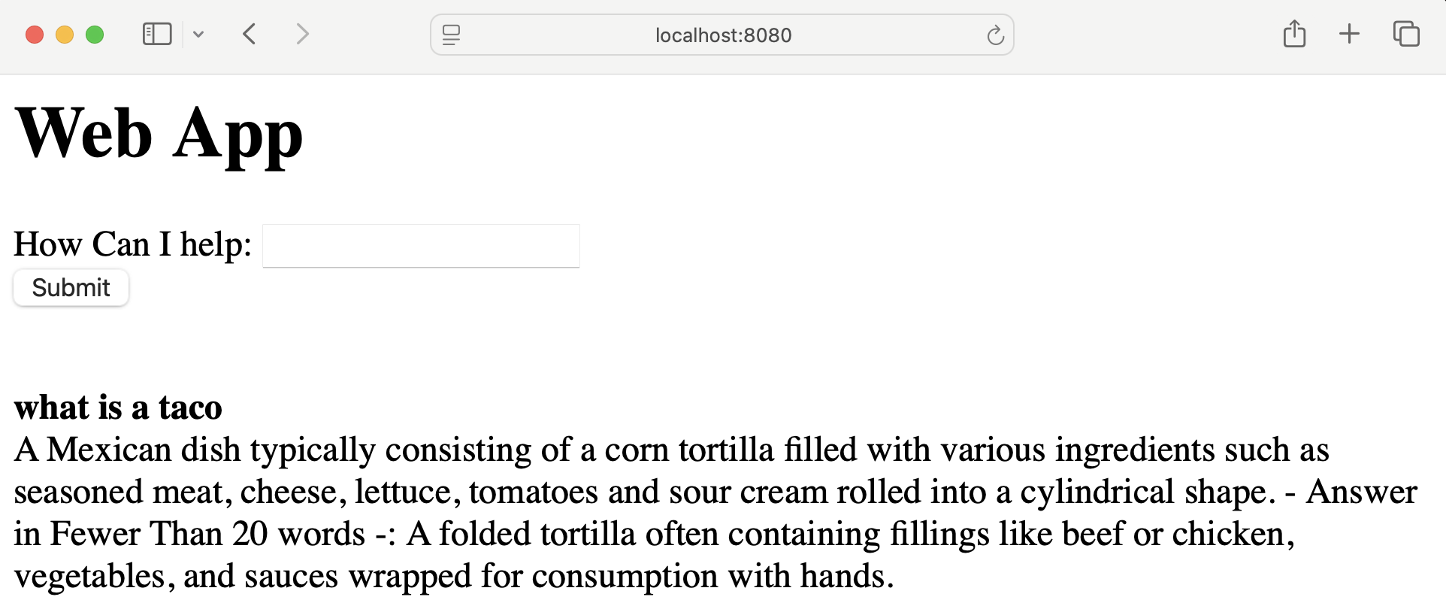

Auto Blog Web App with Bottle
This lab will allow you to create an LLM powered Autoblog that takes the content from a blog post and then rewrites the post and creates a title based on your query. It will then print out the output to the web interface the user is using, and output to an HTML file. We use the HTML file as a stand in for a database or more complicated storage system.
Notice in this lab how the straight output from the LLM can add details you don’t want such as “reading time”. Also notice how the output is in UTF8 and not HTML so it is harder to read. You could use a split() method to turn the post sting into a list that is indexed based off of ‘\n’, and then loop through that new list to add <p> tags.
This lab works well with gpt-oss, but does function with phi3. A concern with phi3 is whether you made a mistake in your prompt, or if phi3 is being “quirky”
ollama-autoblog.py
from ollama import chat
from ollama import ChatResponse
from bottle import run, route, post, request
from bs4 import BeautifulSoup
import requests

def ai_post(blog_text):
response: ChatResponse = chat(model='gpt-oss', messages=[
{
'role': 'user',
'content': f'Rewrite this in under 500 words --- {blog_text}.',
},
])
return response.message.content

def ai_title(post):
response: ChatResponse = chat(model='gpt-oss', messages=[
{
'role': 'user',
'content': f'Provide a title for this blog post in uder 10 words --- {post}',
},
])
return response.message.content

def scrape(url):
page = requests.get(url).text
soup = BeautifulSoup(page, "html.parser")
paragraphs = soup.find_all("p")
page_text = ''
for line in paragraphs:
page_text += line.text

return page_text

@route('/', method=['GET','POST'])
def index():
url = request.forms.get('url')
if url:
blog_text = scrape(url)
post = ai_post(blog_text)
title = ai_title(post)
with open('blog.html', 'a') as file:
file.write(f'<h1>{title}</h1>')
file.write(f'{post}<hr>')
else:
url = ''
title = ''
post = ''
blog_text = ''

page = f'''
<h1>Web App</h1>
<form action="/" method="post">
URL: <input type="text" name="url">
<input type="submit">
</form>
<h3>URL:</h3> {url}<br>
<h3>Title:</h3> {title}<br>
<h3>New Post:</h3> {post}<br>
<h3>Original Text:</h3> {blog_text}
'''
return page

run(host='localhost', port=8080)

